Røde Wireless GO II
Operating Instructions

Full details: https://rode.com/wirelessgoii/learning-hub

Quick Set-Up:
- Plug Receiver into Laptop
- Turn Transmitter and Receiver “On”
- Select “WIRELESS GOTO II RX” when setting up audio. If using a webcam, be sure to disable that mic to avoid echo or feedback.
- Attach transmitter somewhere close to the centerline of the body (to cut down on doppler effect when rotating the head)

When using with Webcam:
- Plug Webcam into laptop
- Position Webcam (either on stand or on screen)
- In “Video Settings” choose “C922 Pro Stream Camera”

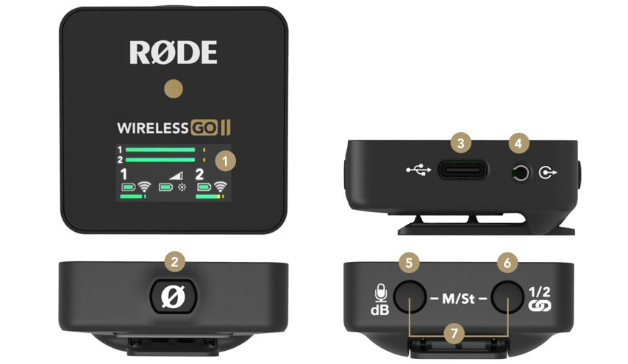
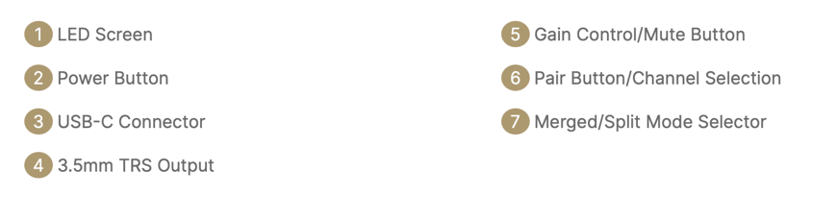

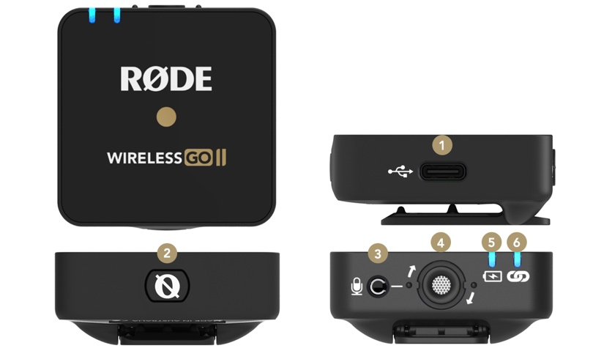

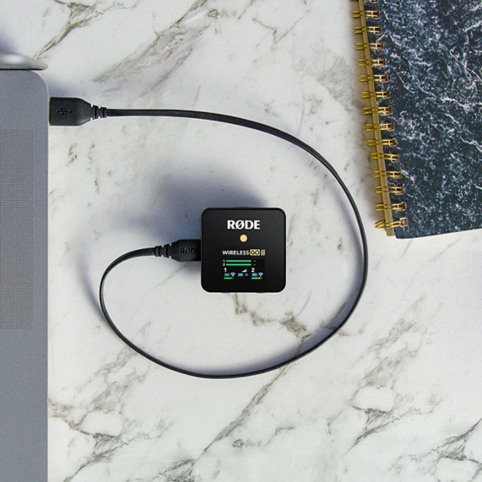
Connecting to Computers
Use the supplied USB-C to USB-A cable to connect the Wireless GO II receiver to any computer with a USB-A input (use USB-C to USB-C cable for computers with a USB-C input), then go to your audio settings and select ‘Wireless GO II RX’ as your input device. This essentially turns the Wireless GO II receiver into a wireless USB audio interface.

