INTRODUCTION

I first fell in love with Sylvia Plath’s work—and poetry in general—at the same age as everyone else: during my first year of college. I was full of post-adolescent angst, on a clichéd mission to (as they say) find myself, when introduced to The Bell Jar and the trials of Sylvia’s thinly-veiled protagonist Esther Greenwood. It was the first time I ever felt such a connection. There was another person who had the same thoughts and fears as I did. But I was not from New England. I was from a small town in southern Oregon. I did not arrive at a prestigious university with a parade of scholarships and accolades. I stumbled into a state school to escape an abusive relationship, saddled immediately with tens of thousands of dollars in student loans because I was considered “financially independent by the government due to parental abandonment” (living in a car and graduating high school through a community college’s remote study program at 16 helped with that claim). I had no idea what a scholarship was, so I was a little a lot behind Sylvia in that regard. I didn’t spend my teenaged summers nannying for wealthy families. Instead, I was using a fake I.D. so I could get a “good job” at the mall (The Limited—yes, it was the 90s) and rent a one-bedroom apartment from landlords who looked the other way. All of this, and yet I still felt sympathy—empathy—for a white middle-class girl who became one of the most famous writers of the century.
Oh, I should mention, I’m not white. I’m Aniyunwiya, or as many people say, “Cherokee,” but I can pass and went platinum blonde when I turned eighteen. Why settle for a “Platinum Summer” when you can have a platinum decade? But, like my first and best literary love, I, too, went back to my natural color eventually, a hue deemed more “studious,” “earnest”—and deserving of a Fulbright. So, maybe Sylvia—or Sivvie as some close friends called her—and I weren’t so different after all. She was like the big sister I never had: encouraging, beautiful, talented, and always right even when she wasn’t. Janet Badia says that Sylvia’s writing “inspires young women especially, and it inspires them not only to read but to write” (83). Is that what it was? Well. It wasn’t a bite on the cheek, but every relationship has a beginning.
My first year as an undergrad, I declared my major in Criminal Justice. I don’t know why. I was raised on horror movies and books, so perhaps that had something to do with it. Or maybe the idea of becoming a mortician and mostly dealing with dead people sounded achingly peaceful and I figured “criminal justice” was close enough. I’ve picnicked at two graves in my life, Sylvia’s and Franz Kafka’s, and both were excellent company. And listeners. But I almost flunked out after my first semester and begged someone in admissions for a second chance. When granted, I switched to literature because that’s what it was always supposed to be. Sometimes destiny steps in and demands that you listen, change course, because you took your free will too far. I’ve always known I was a writer. I have poems that I wrote at six years old, but when I had to declare a major, this was during a time when getting a literature degree was a one-way ticket to being a teacher. And I was a terrible teacher (still am). Still, I took a deep breath and listened to the old brag of my heart.
Full disclosure: I did not actually study Sylvia’s work in a classroom as an undergraduate or during my first master’s degree. I was exposed to many other writers and poets during these years, and still fondly remember all the poems I had to memorize in one undergraduate workshop where the professor said poetry memorization is a life skill because “if you’re ever in solitary confinement, you need beautiful words besides your own in your head.” It’s true. I’ve never been in solitary confinement, but a New York subway with no connection is, I imagine, the same thing. I recommend “Lady Lazarus” for long subway and airplane rides. Or “Daddy” depending on your mood. During my undergraduate years and throughout my twenties, my relationship with Sylvia was a private one, taking place entirely in my head. I read everything she had ever written, then read it again, but The Bell Jar will always be my first and favourite dance with her. However, unlike the thousands of others who found themselves in this book, it was not Esther’s grappling with her love life (super juicy), depression, or suicidal leanings that hammered so close to home for me. It was her obsession with food.
The Bell Jar and much of Plath’s poetry, letters, and diary entries are stuffed with such an intense preoccupation with food, hunger, and a teetering between gluttony and starvation that it’s impossible to ignore—once you see it. And I totally got her obsession. I spent hours as a pre-teen on the weekends locked in my room, reading Stephen King or Dean Koontz, and eating entire boxes of Hot & Spicy Cheez-Its in my garage-sale waterbed. I would take breaks to sneak into the kitchen, avoiding my always-hovering mother, and swipe slices of bread slathered with Sandwich Spread and piles of American cheese.
Sylvia wasn’t much different at that age and I’m sure she would have approved, had she lived to experience Cheez-Its. In letters from summer camp to her mother, Aurelia Plath, she documented eating unbelievable amounts of food. At 13 years old, on July 5, 1946, she wrote:

I should be gaining weight! Just listen to what I had for lunch:
Two bowls of noodle soup
One slice of bread
Two helpings of potatoes and cabbage
Two helpings of salad (including lettuce, cheese, peas, eggs)
Three bowls of custard
One cup of milk—two of cocoa
I’m eating so much, no matter what, or how horrible it is, that I can hardly walk after each meal. (NEED CITATION—PHOTO FROM VISIT TO LIBRARY)

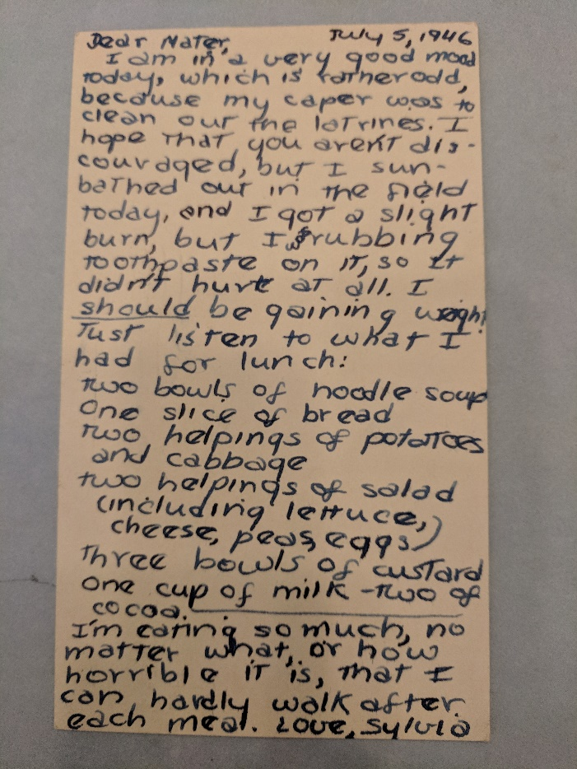
NEED CITATION

This was not an unusual amount of food for her, at that age or any age. As for me at thirteen, I would have thought, Wasn’t Sylvia’s adoration of food … normal? Isn’t it normal to sometimes hurt after eating? In fact, we don’t know how “normal” (common) binge-eating is because eating disorders, including binge-eating disorder (BED), bulimia nervosa (bulimia), and anorexia nervosa (anorexia), are notoriously under-diagnosed, mis-diagnosed, under-treated, and under-insured. Now, nobody can say whether that letter proves Sylvia was a binge-eater in the medical and diagnostic sense, but it’s undoubtedly an unusually large amount of food for a single meal. What I am certain of is that there’s a lot more of us than they realize—and by “they,” I mean doctors and the general public. BED wasn’t even added to the Diagnostics and Statistic Manual of Mental Disorders (DSM) until 2013, so you can imagine how far we still have to go.
Food isn’t what most people think of when they hear “The Bell Jar.” But it should be. It isn’t a memoir (yes, she admitted it)-cum-novel about working in fashion, living in New York, dating, and what we now call a quarter-life crisis. It’s about hunger. That same hunger we all have. Examples of Esther’s engrossment with food abound, from the binge-eating caviar scene to an entire paragraph dedicated to describing the perfect browning of a hot dog before she secretly buries it in the sand (22, 47). I’m going to let the obvious Freudian/sexual innuendo of an interred wiener slide for now—we’ll get to the complicated relationship between food and sex later. But what about the whole fig tree scene? Even if you haven’t visited The Bell Jar in decades, you probably vaguely remember it. Esther sits, in a dream, beneath a fig tree with each fruit representing a possible future. She can’t choose so, you know, the figs die, and she starves to death. But what you might have forgotten is that Esther also does a little dream analysis in chapter seven:

I don’t know what I ate, but I felt immensely better after the first mouthful. It occurred to me that my vision of the fig tree and all the fat figs that withered and fell to the earth might well have arisen from the profound void of an empty stomach. (63)

It’s not just food that’s important to Esther, to Sylvia, to me, and to everyone. Hunger is its counterpart. One cannot exist without the other. Gitanjali Shahani neatly summarizes the importance of food for some literary characters which can include, I assert, Esther: “Some of their most memorable words and scenes are gastronomic” (3). True, but this doesn’t just apply to literary characters. It applies to all of us. Think back to your most memorable moments. How often was food involved or, even more importantly, at the center?
Making and devouring birthday cupcakes, licking the spoon. Your wedding cake. How many flavors did you try, how much did you spend? It was a critically important decision. The first time you had a drink. The first time you had a drink you liked. When you go camping and all food just tastes so much better—s’mores, half-burnt hot dogs, potatoes suffocated in butter and cocooned in foil over the flame. When you tried whipped cream in bed and kind of thought you’d rather go get ice cream to go with it than finish what you’re doing (no, we’re still not to Freud and sex yet). The way your mom or dad or grandma or grandpa made a certain dish. They’re gone now and you can’t ask them and even if you have the recipe, it’s not the same. The way a sandwich just tastes better when someone who loves you makes it. The first time your baby devoured something besides milk or formula. You know what it was, even if your baby has long been grown. Your favorite dish from that place you visited a long time ago and you want to go back and have it again, but you also don’t want to because what if it’s not as good and then the whole memory is ruined. Food matters. So, let’s dig into some food matters.

